Background :

It has long been observed that birds and fish and even lower organisms such as a bacterial colony or a collection of cells exhibit coherent large scale collective motion. (Images from left to right : Birds , fish bacteria and epithelial cells in collective motion).

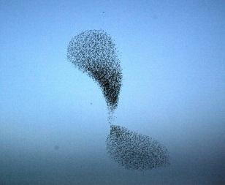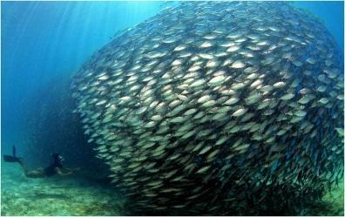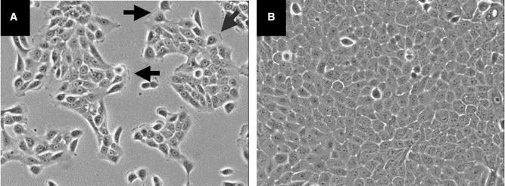

Within the biology and animal behavior community, this was a big deal and a lot of people were looking into mechanisms for this phenomenon to happen. In cognitive animals such as birds and fish, there was a search for a leader of the flock/school. In the context of lower level systems there were searches for chemical signaling mechanisms and biochemical pathways. But most of these studies until recently (i.e., if 30 years is recent) focused on looking for non-local interactions that will act on the scale of the colony/swarm.

But physicists know that you do not need long range interactions to get long range correlations. Phase transitions in physical systems are the standing example. We know that all the spins in a magnetic material “decide ” to go into a ferromagnetic state at a particular temperature but the Hamiltonian governing the dynamics is entirely local (nearest neighbor coupling only).

The first model for flocking from the physics community that put forward this idea was the Vicsek model, that was a generalization of the x-y model for magnetism to moving objects. It showed that the system undergoes a phase transition for a disordered state (where everybody is doing their own thing) to an ordered state (where there is coherent motion among the whole group) as a function of noise, which plays the role of temperature in these inherently non-equilibrium systems. This exercise is intended for us to explore this model.

The model :

The simulations you will be working with implement a variant of the traditional Vicsek model. In the simulation a collection of particles move around in a two-dimensional periodic box (i.e. a particle that exits through the right edge will reenter through the left - this makes it possible to study bulk behavior while only dealing with a small system). Each particle has a preferred direction, and propels itself with a constant force along that direction.

Two factors serve to change their directions of travel. First, random noise perturbs the directions so that an isolated particle will execute a meandering persistent random walk on long timescales. The second is a sort of peer pressure - each particle examines its “neighbors” (particles that are within a certain distance) and exerts a torque to turn its own direction of travel to match the average direction of its neighbors’. In some circumstances this can lead to a sort of flocking behavior in which all particles in the system travel coherently in the same direction.

However, this behavior is not assured. If each particle can “see” only a short distance, then interactions are rare and a particle spends most of its time wandering around randomly. This situation will lead to a globally disordered state where all directions of travel are equally likely. At the other limit, if each particle can “see” many of its neighbors at once, then large flocks of particles will quickly align, eventually leading to a globally ordered state. In the literature there has been a long and still-unresolved debate about whether this phase transition is continuous or first-order (i.e. whether the global flocking emerges smoothly as the range of alignment increases, or whether it jumps discontinuously from near-zero to a finite value).

The exercise:

The template file <alignment.txt> is preset to simulate a periodic box with enough particles (**N**) to produce a reasonable estimate of the degree of alignment. The simulation will initialize the particles with random orientations, which over time will either globally align or not. It will also keep track of the global alignment parameter, which is calculated by summing the direction vectors of all particles in the system, taking the magnitude of the result, and dividing by N - the resulting scalar will be near zero if the directions are oriented randomly, and near one if they are all aligned.

Each run will output a time-series of the global alignment parameter, both to the terminal and to a file named <alignment_R[*]_Dr[*].out> where * stands for the values of the range **R** and angular diffusion constant **Dr** used for that particular run. Use the Mathematica notebook **analyzeAlignment.nb** to look at the simulation output and calculate a time-averaged alignment parameter.

Modify the parameter **R** in the template file to change the range that each particle can “see”. Try very small values to see what happens when interactions are infrequent, and large values to see global alignment emerge. Create a text file in which you record the alignment order parameter as a function of R, for example:

--------------------

0 0.123

0.02 0.232

0.05 0.6623

0.1 0.834

--------------------

Finally, feed this file into the mathematica notebook **plotAlignmentPhase.nb** to plot the averaged order parameter as a function of the range **R**. You should see a sharp transition between a non-aligned system at small **R** and an aligned system at large **R**. If necessary run more simulations for values of **R** close to the transition to produce a more complete picture.